

**Green University of Bangladesh**

**Department of Computer Science and Engineering (CSE)**

**Semester: (Spring, Year:2024), B.Sc. in CSE (Day)**

**Lab Report NO #02**

**Course Title: Data Communication Lab**

**Course Code: CSE 308 Section: 221 D20**

**Lab Experiment Name:** Implementation of NRZ-L.

**Student Details**

| **Name** | | **ID** |
| --- | --- | --- |
| **1.** | Tanvir Ahmed | 221002461 |

**Lab Date : 14/5/2024**

**Submission Date : 14/5/2024**

**Course Teacher’s Name : Md. Romazan Alom**

| **Lab Report Status**  **Marks: ………………………………… Signature:.....................**  **Comments:.............................................. Date:..............................** |
| --- |

**Introduction:**

We have the task of non return to zero level implementation where we map binary 1 to logic level high and map binary 0 to logic to level low. We can do vise varsa although we use the first way here. We use this technique to convert a binary string (that is our message or data)/digital data to a digital signal to transfer through a medium/channel to the receiver. Today I am going to use MATLAB software to convert the digital data to a digital signal. I am doing the conversion using the functionality of NRZ-L in this report.

Source code:

bits = [1 0 1 1 1 0 0 1];

bitrate = 1;

n = 10000;

T = length(bits)/bitrate;

N = n*length(bits);

dt = T/N;

t = 0:dt:T;

x = zeros(1,length(t));

**for** i=1:length(bits)

**if** bits(i)==1

x((i-1)*n+1:i*n) = 1;

**else** x((i-1)*n+1:i*n) = -1;

**end**

**end**

plot(t, x, 'Linewidth', 3);

output:

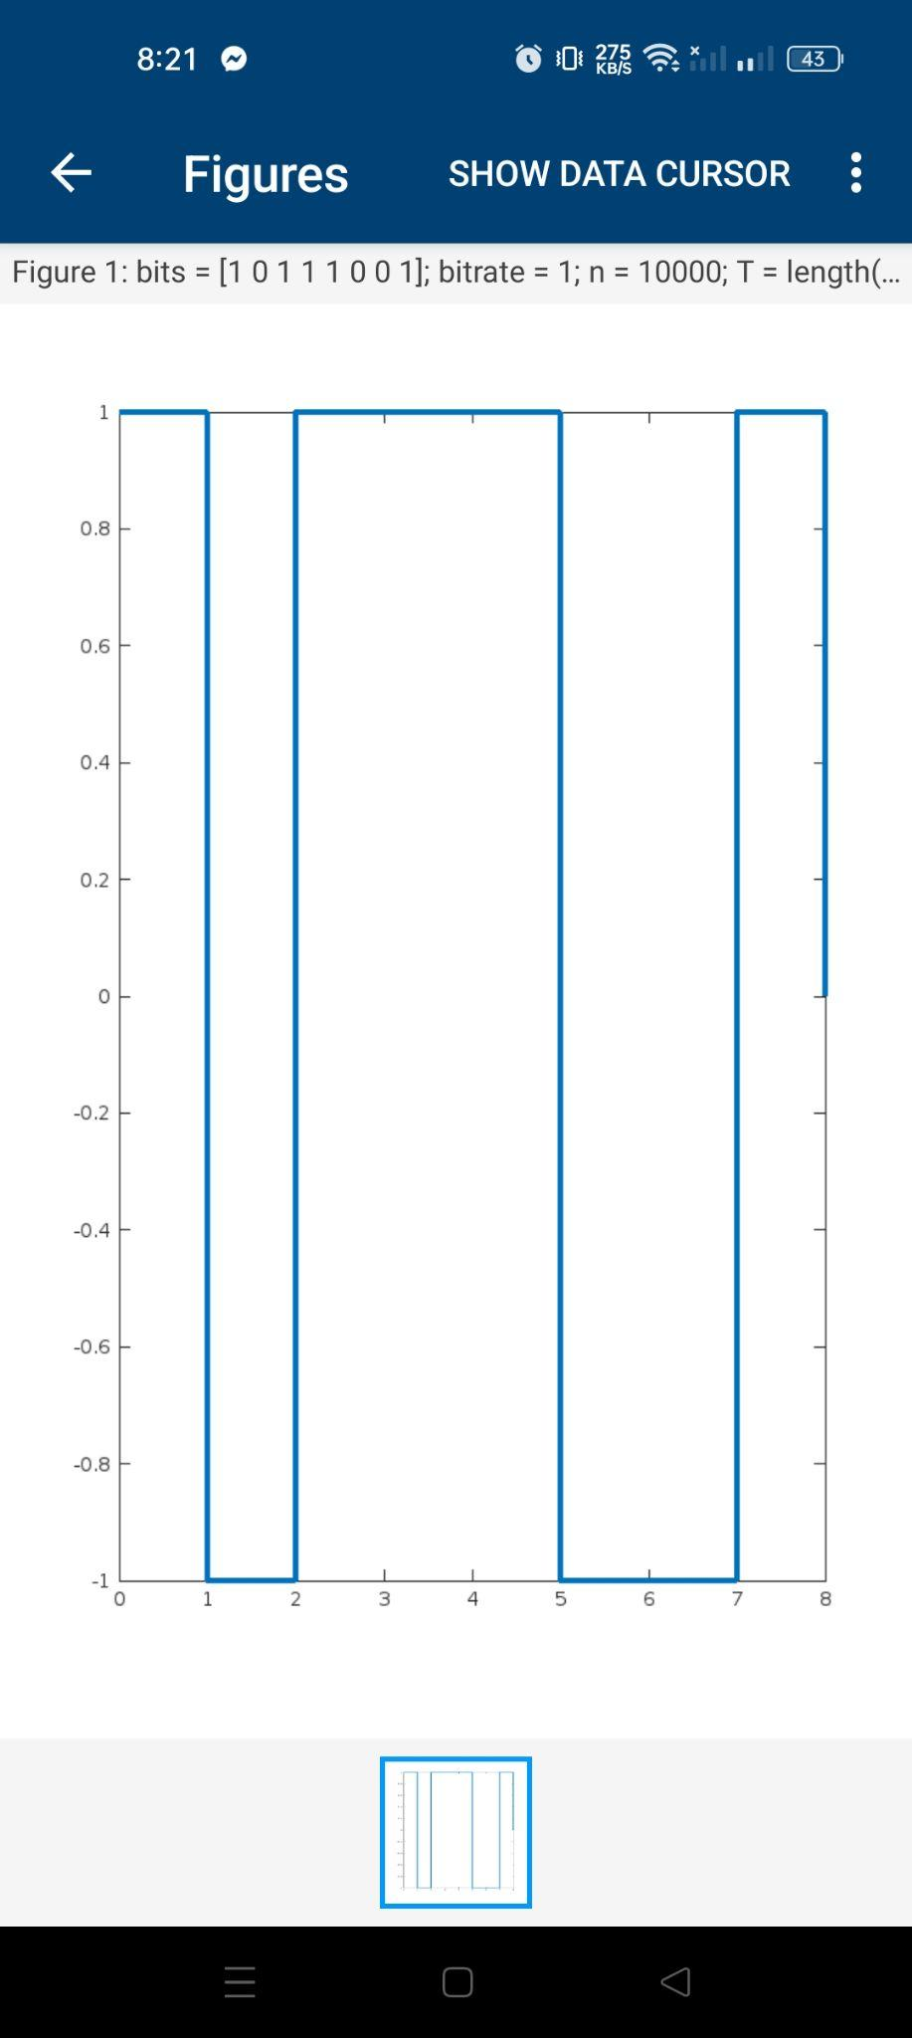

**Discussion:**

I have completed the task properly, and the output showed correctly. I took some help from the previous class learning and lab manual to complete the task. I have learned the NRZ-I during the last class. I rewrote that code and changed the NRZ-I code to NRZ-L based on the NRZ-L functionality to achieve the objective. Finally, the output came properly.